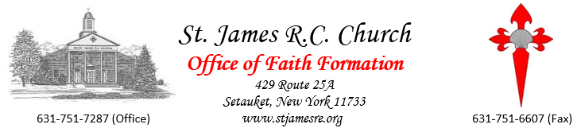

Dear First Communion Families -

I have good news to share with you.

We have our First Communion dates! Now, please read everything over carefully. Fr. Jim and I have planned every detail to ensure that we will be able to have beautiful liturgies with our families. These are the details I can share with you:

1) They will be taking place starting in June and continue into the summer. We are hopeful that waiting this long will allow you to be able to celebrate with family with minimal stress about the virus.

2) We are currently permitted up to 50% of capacity and our plan is to do it by class within the Sunday liturgy. Every First Communicant will be allowed 10 guests. This is exactly what we would allow for the Saturday group First Communions.

3) If for any reason you cannot make your assigned day, please know that your child can receive at any Saturday or Sunday liturgy from the beginning of June until infinity. We will limit those to 2 children per Mass for the time being so you must let us know ahead of time to see if that Mass is available. Please choose 2 in case your first choice is already filled. Please put your request in writing and email to REOffice@stjamesre.org and follow-up with a phone call. We will do our best to accommodate your request, please be mindful we are limited by number restrictions.

4) Regardless of when your child receives, everyone will be asked to wear masks during the liturgy, only to be removed during the reception of the Eucharist. Please note that we are taking every precaution necessary to ensure the safety of everyone.

5) You can hang your banner (not mandatory if you do not do it) on the end of your pew. You are picking up the banner kits at reconciliation. After, we will have them in the Faith Formation office. We will have rehearsals and go over the details of the day.

Please remember that as state mandates change, so too might our plans need to be tweaked, so please be patient with us.

Please continue to join us every Saturday at 5PM or anytime after to celebrate Mass together on our Facebook page (facebook.com/stjamesre) if you have not already started joining us in person.

You and your families continue to be in our prayers, and we cannot wait to celebrate with you!!!

Stay well, stay safe.

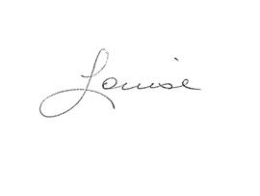
Blessings & Warmest Regards,

(Communion dates on reverse side)

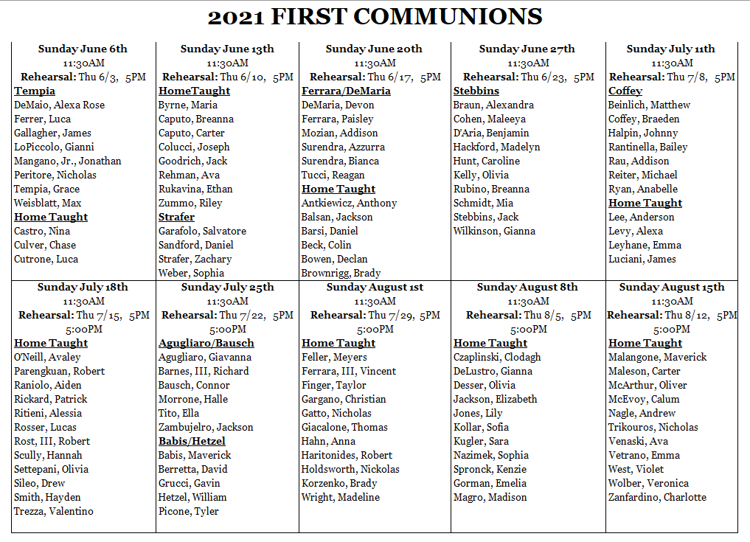

1st communicant +10 guests

